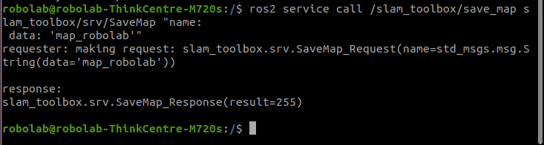
https://github.com/turtlebot/turtlebot4_robot/tree/humble/turtlebot4_bringup

fatal: could not create work tree dir 'turtlebot4_bringup': Permission denied
https://support.franka.de/docs/franka_ros2.html

https://turtlebot.github.io/turtlebot4-user-manual/tutorials/driving.html –usar el mando
https://turtlebot.github.io/turtlebot4-user-manual/tutorials/generate_map.html –generar mapa
https://turtlebot.github.io/turtlebot4-user-manual/tutorials/navigation.html --navegación

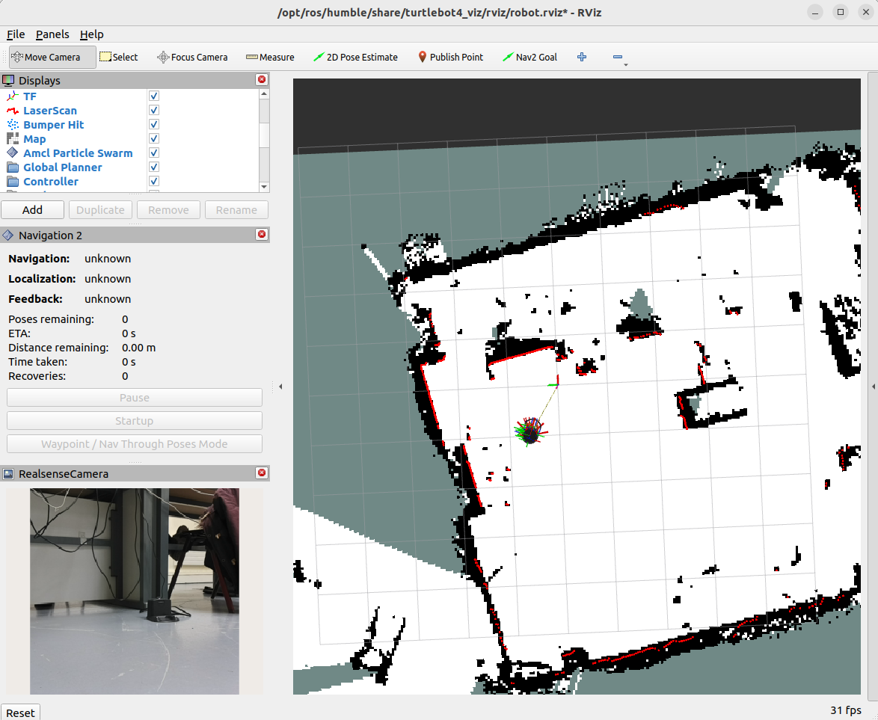

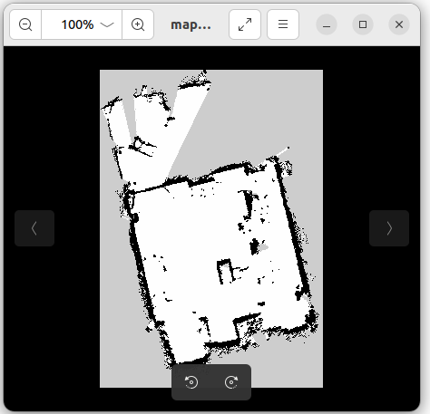

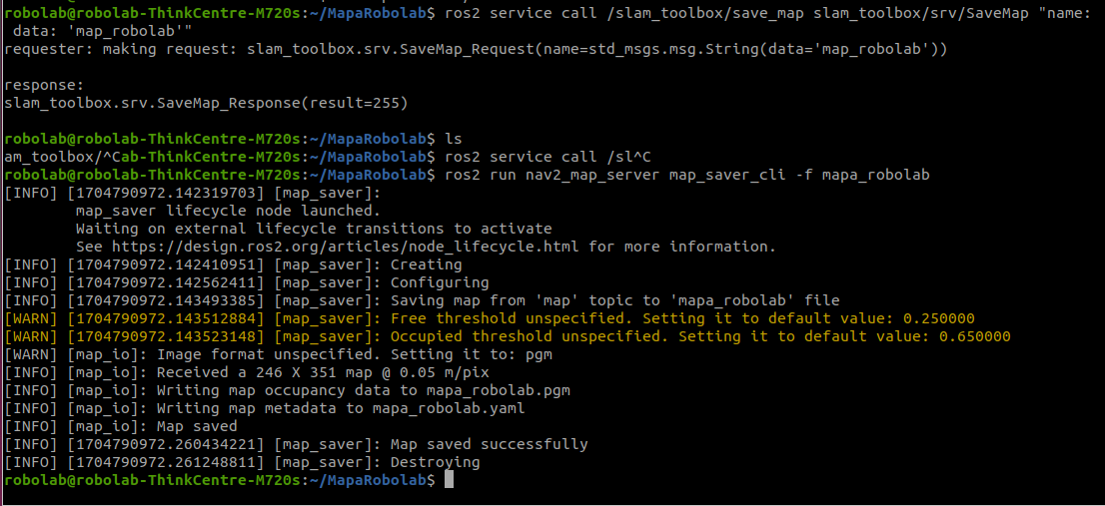

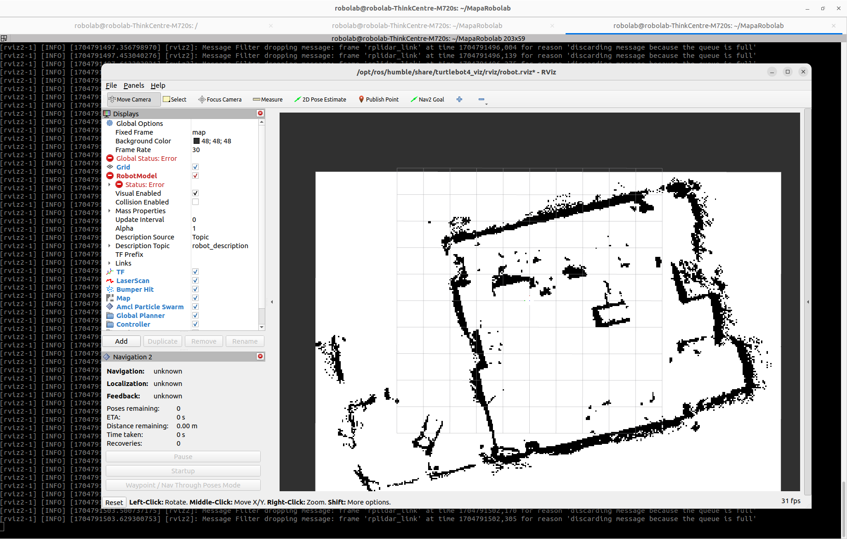

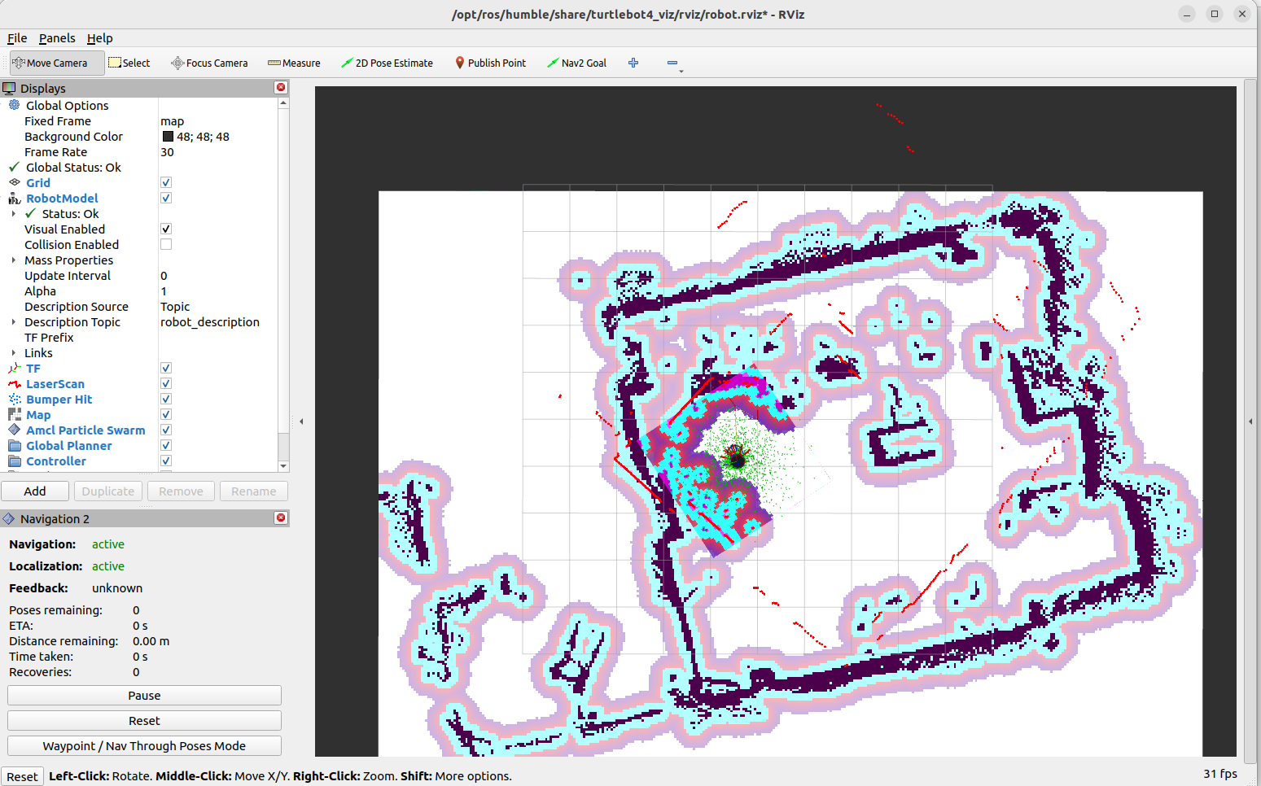

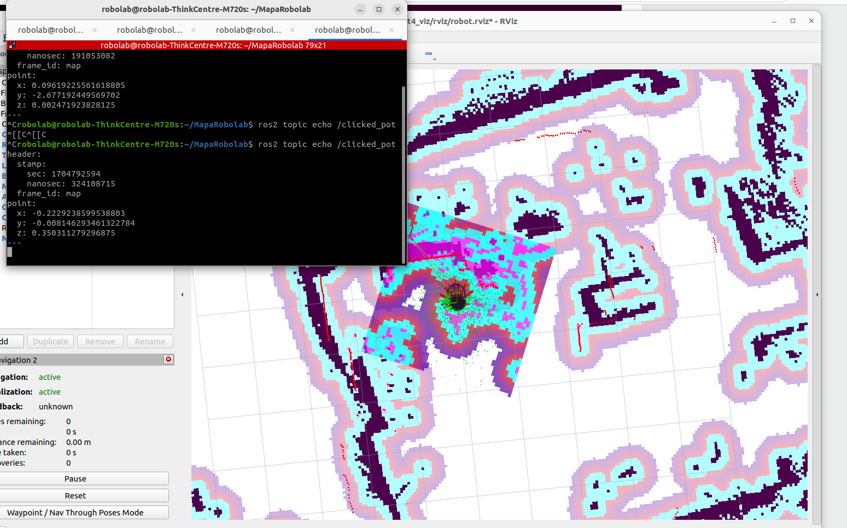
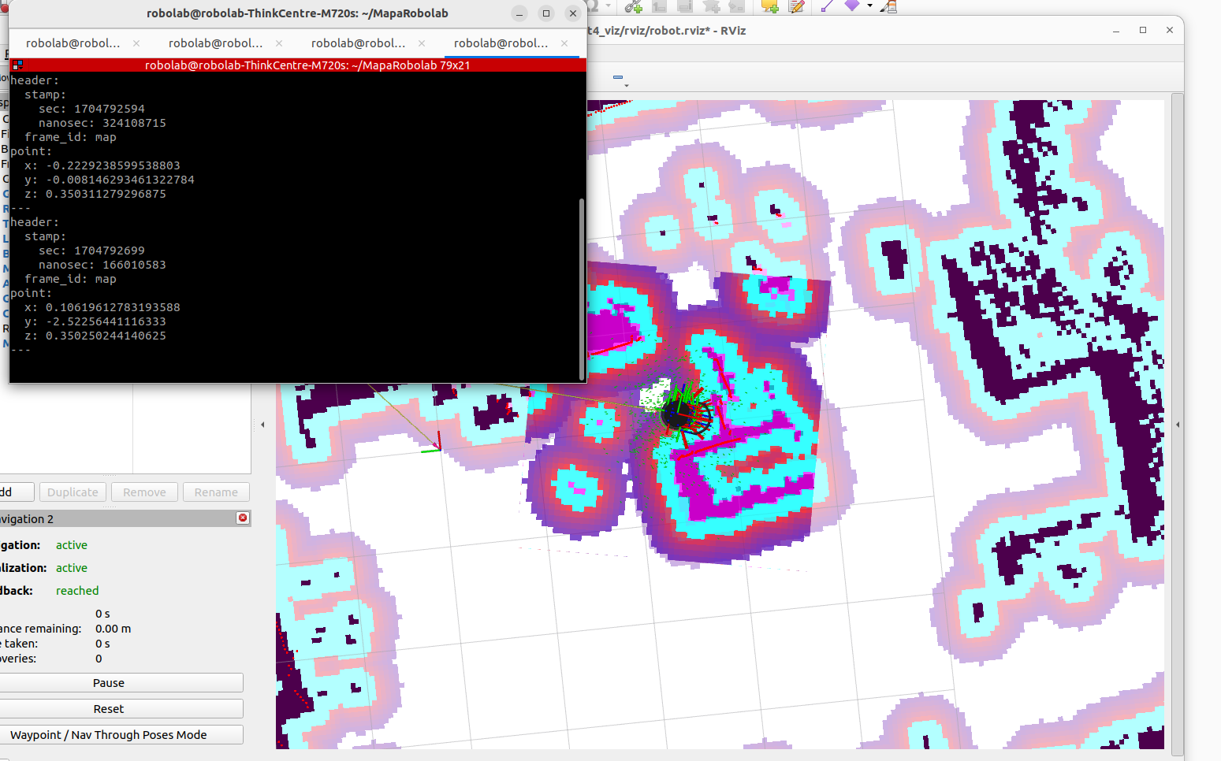

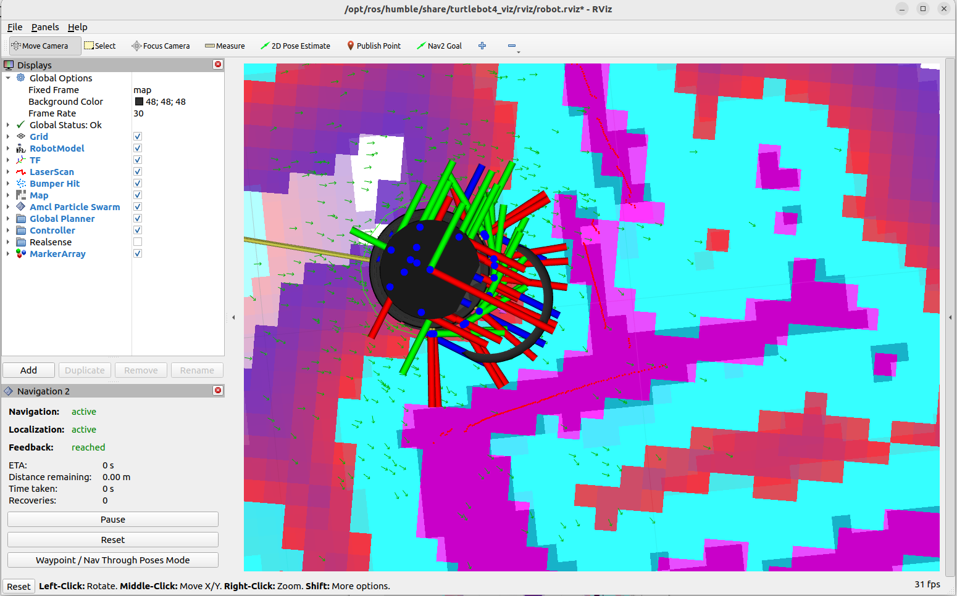

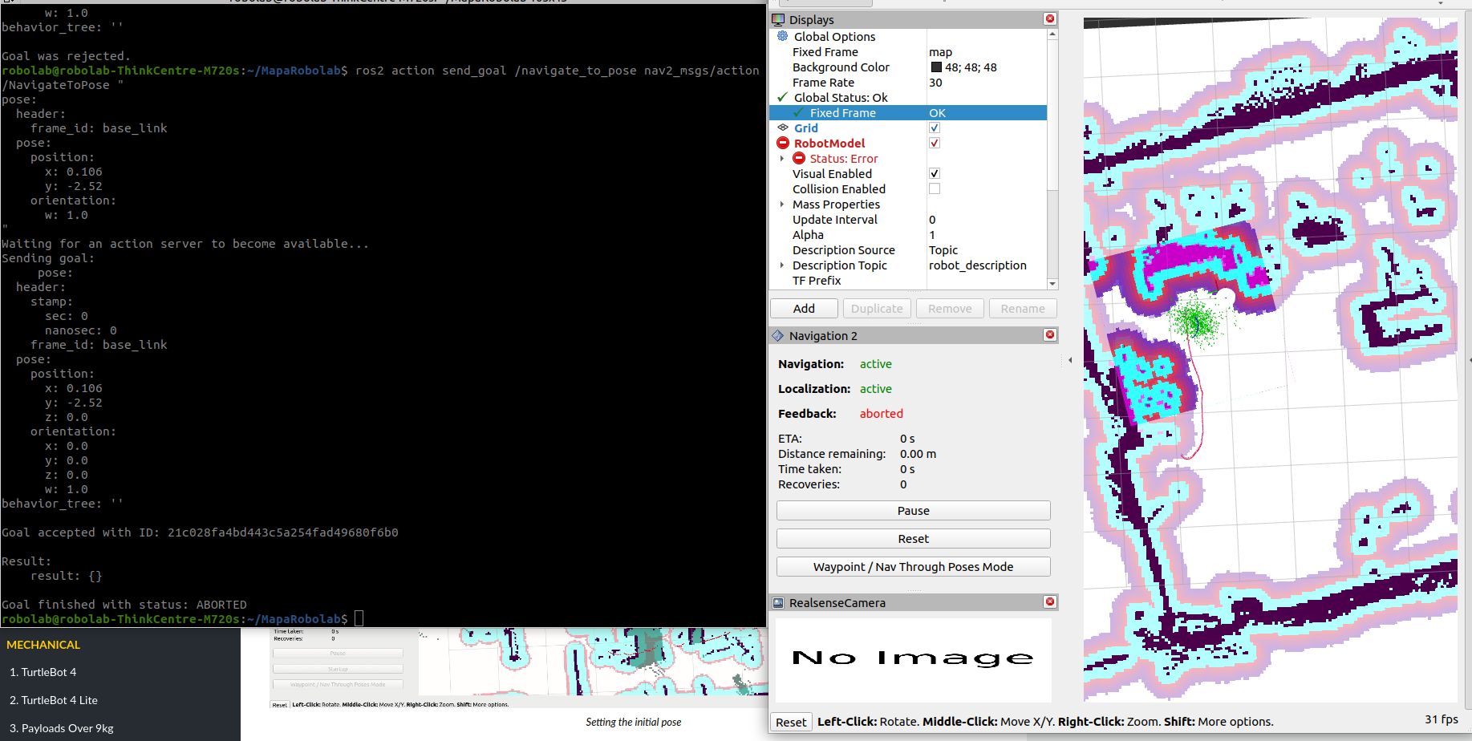

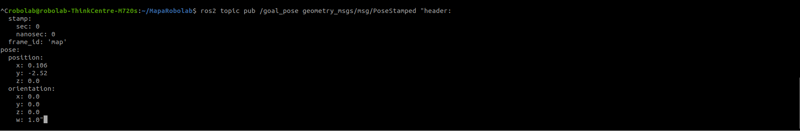

ros2 topic pub /goal_pose geometry_msgs/msg/PoseStamped "header:
stamp:
sec: 0
nanosec: 0
frame_id: 'map'
pose:
position:
x: 0.106
y: -2.52
z: 0.0
orientation:
x: 0.0
y: 0.0
z: 0.0
w: 1.0"

